**Dishwasher, Dryer and Cloth washers**

**Dishwasher**

Dishwasher operates with a sequence of operations depicted in the figure bellow, first filling with water for about 15 minutes with a constant power (P1), then provide electric heating increasing the power to (P2), the time of this period depend if is connected to hot water or cold water goes into the dishwasher [1]. After that, hot water and detergent are sprayed over the dishes, alternatively draining and refilling with rinse water (P3). Then the dishes are dried using the electric resistance element again (P4) and finally (P5) uses the hot air remaining in the dishwasher.



According to [1-3] around 55 percent of the energy used by a dishwasher goes to heat water even if is connected to water heater, and 65 percent if cold water goes into the dishwasher. And the period P3 depend on the efficiency of the dishwasher.

The model presented in this simulator try to fit the figure presented on the top with the use of the yellow energy guide under standard conditions and with the use of the entries given by the user.

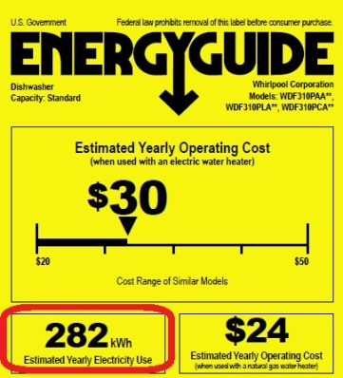

Total power consumption during normal or standard operation can be found on the yellow energy guide labels which show an estimate of how much electricity that particular appliance will use over a year, refer to the following figure. This energy guide is obtained at the moment the appliance is bought.

**Dryer**

All clothes dryers work the same way; the big difference is in their energy source: gas or electricity. Only electrical ones are considered on this simulator, since electrical dryer are the most common used in North America.

Unlike other appliances, the energy used by clothes dryers doesn't vary significantly from model to model. That’s why they usually **do not display energy-rating labels**. An example of a dryer consumption pattern is shown in the figure bellow [1-3], normal power is in the range of 2000 to 2500 Watts during P1 period and 500 Watts for P2.



In this simulator 2500 Watts is used for the first 60 minutes of use, and 500 Watts for the rest of its simulation.

**Washer**

The cloth washing process is controlled by a step timer or an electronic control device and lasts between about 15 minutes and 2 hours, depending on the washing program chosen.

Electrical energy is used mainly for driving the drum motor and heating up the water, if it was not hot enough; in spite of the fact that about 3/4 to 2/3 of the water is used as cold water for rinsing. An example of the washer average power demand profile is given in Figure 2.13 for 15 minutes resolution.



In the presented figure three main sections are presented with constant power. P1 and P4 are used to filling and draining with rinse water. While P2 and P3 are used to heat water if this function is selected.

The model presented in this simulator fits this type of behavior according to the yellow energy guide label and with the user inputs.

alternatively draining and refilling with rinse water

has two distinct sections; a main cycle and an end section. The main cycle is between 10 and 30 minutes in duration, with a constant power draw of 2000 W. The end period is generally much longer, with an alternating power draw of either 200 or 0 W.

According to [1-3] around 55 percent of the energy used by a dishwasher goes to heat water even if is connected to water heater, and 65 percent if cold water goes into the dishwasher. And the period P3 depend on the efficiency of the dishwasher.

$$EER=3.412\frac{Q_{in}}{W_{in}}=\frac{Q_{in}}{\left(Q_{in}+Q_{out}\right)}$$

$$\frac{dT_{w}}{dt}=\frac{Q_{s}}{C_{w}}+\frac{ T_{out}}{R_{w}C_{w}}+\frac{ T_{i}}{R_{w}C_{w}}-\frac{2T_{w}}{R_{w}C_{w}}$$

$$\frac{dT_{i}}{dt}=\frac{Q_{in}}{C_{i}}+\frac{Q_{ac}S\left(t\right)}{C_{i}}-\frac{T_{i}}{C_{i}}\left(\frac{1}{R_{w}}+\frac{1}{R_{c}}\right)+\frac{T_{w}}{{C_{i}R}_{w}}-\frac{T_{out}}{C_{i}R_{c}}$$

The peak reduction strategy does not attempt to reschedule deactivated loads at a later point; they are simply dropped

load was disabled at a given time step it is scheduled to restart at the next available time step.

There are three types of residential load management strategies.

Peak reduction, in which the load is simply dropped.

Peak shifting, where the load is dropped and scheduled.

and the valley filling strategies, where propose is the use of energy during off-peak

**Payment Confirmation**

Your payment of $50.84 has been applied to your account#: 231319447901.  
Your confirmation# is 012359. Please note for your future reference.